1. **Understanding data and background**

<https://www.kaggle.com/competitions/lish-moa/discussion/184005>

We have been given data collected from a cell-based assay which records levels of gene expression and cell viability. Our objective is to use the patterns in this data to predict the mechanism of action (MoA) of a drug. This is a multi-label competition where some rows can be linked to multiple targets, instead of multi-class. The data comprises of 772 gene expression features labeled as "g-" that represent the expression of one specific gene, and 100 cell viability features labeled as "c-" that represent the viability of one particular cell line. The original data was normalized using [quantile normalization](https://www.youtube.com/watch?v=ecjN6Xpv6SE&ab_channel=StatQuestwithJoshStarmer).

1. **EDA**

The majority of the treatments in the dataset are compound treatments (referred to as "trt_cp"), while only around 8% are control perturbation treatments (referred to as "ctl_vehicle"). The controls do not have any Mechanisms of Action (MoAs).

The "cp_vehicle" column distinguishes between treatment (with drugs) and control (without drugs) experiments. DMSO is a common control vehicle that is unlikely to have any significant biological effects. We can use the control data as negative samples during training or normalize the treatment features.

Timing - The cp_time column indicates the amount of time elapsed between adding the drug and when the measurement was taken. The effect this has on the data will differ depending on the mechanism. For example, some drugs will have an irreversible effect that can still be seen 72 hours after dosing. Other drugs will have lost all effect by that point and may be indistinguishable from controls.

Dosage - The cp_dose column indicates the dose level used in the experiment. Generally a higher dose will have a stronger effect.

All the targets are binary columns, indicating whether a certain cell type responds to the drug, or not. Some target classes also measure the type of response; e.g. there is an “adrenergic_receptor_agonist” class and an “adrenergic_receptor_antagonist” class. Those should probably not be active for the same sample row.

Our challenge is a multi-label classification problem, and as such the rows (i.e. drug samples) can have multiple MoA’s (i.e. more than one target class can be active).

About 39% of training samples have no MoA annotations at all (e.g. all the target classes have values of zero). This goes a certain way to explain the sparse target dataframe, if 40% of it are completely empty.

The largest group, with a bit more than 50% of samples, has exactly 1 MoA annotation (e.g. one class = one value of “1” in its row).

For more than 1 MoA annotation, we see a tail that extends down to 7 simultaneous MoAs (for 0.03% of cases). Only the case of 2 MoAs is just above 5%, and 3 MoAs is slighly above 1%. Every other case is significantly rarer. Note, that there is no instance with 6 MoAs.

It seems we have 2 outliers here: "nfkb_inhibitor” and “proteasome_inhibitor”.

Most of the targets have 0 correlation. It is worth recalling that the presence of active targets in the samples in very low (mainly 1 or 2 targets per sample).

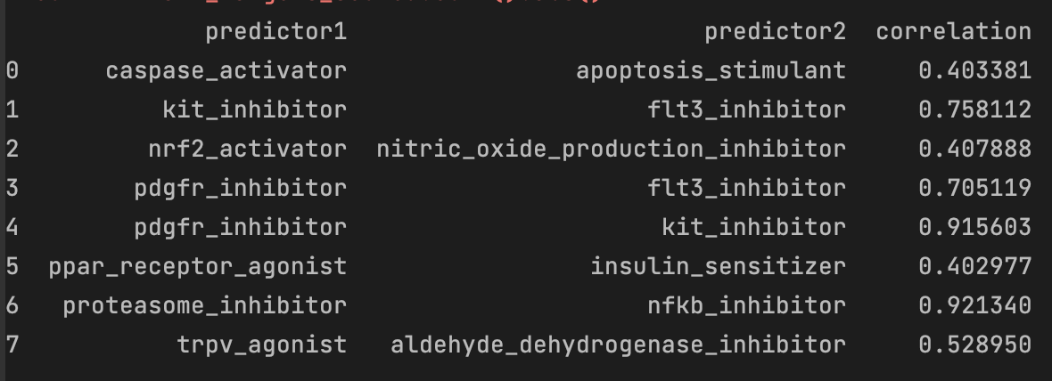However, we notice some yellow dots (high correlation) between some targets. Let's have a closer look over these targets.

Those target pairs must be in the few samples that have more than two active targets. The functionality of these targets and their distribution is something to be taken into consideration because in this case, we have a multi-label classification problem, where the correlation between the labels is also important and the model selection should be based on the labels correlation. Select a model that finds patterns not just in the train data but also in the multi-label target data.